**MUHAMMAD-RAYYAN**

**ME-15**

**SECTION-B**

**LAB-MANUAL: 08**

**HOME TASK**

**CMS: 456847**

#include<bits/stdc++.h>

using namespace std;

// Q: 01

// Finding most repeated elements in an array.

/* int main(){

int n,a,count,Max_count=0;

cout<<" Enter no of elements in the arary : ";

cin>>n;

cout<<" The array elements are : "<<endl;

int sso[n];

for(int a=0; a<n; a++){

cout<<" Element no "<<a<<" = ";

cin>>sso[a];

}

a = 0;

while(a<5){

count = 1;

int b=a+1;

while(b<5){

if(sso[a]==sso[b])

count++;

b++;

}

if(count>Max_count)

Max_count=count;

a++;

}

a = 0;

while(a<5){

count = 1;

int b=a+1;

while(b<5){

if(sso[a]==sso[b])

count++;

b++;

}

if(count==Max_count)

cout<<" The most frequent occuring element is "<<sso[a]<<" occuring "<<Max_count<<" times .";

a++;

}

return 0;

} */

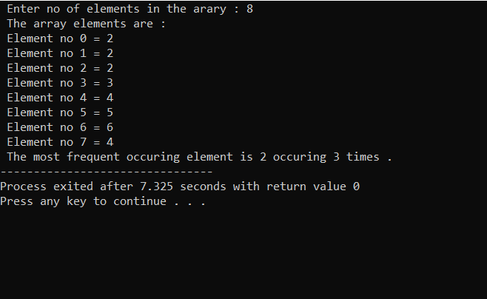

// Q. 02

// Finding largest and smallest value in an array.

/* int main(){

int n;

cout<<" Enter size of array : ";

cin>>n;

int arr[n];

for( int i=0; i<n; i++){

cout<<" Element at space "<<i<<" = ";

cin>>arr[i];

}

int largest = INT_MIN ;

int smallest = INT_MAX;

for( int i=0; i<n; i++){

if(arr[i]>largest){

largest=arr[i];}

}

cout<<" Element with largest value is : "<<largest;

cout<<endl;

for( int i=0; i<n; i++){

if(arr[i]<smallest){

smallest=arr[i];}

}

cout<<" Element with smallest value is : "<<smallest;

return 0;

} */

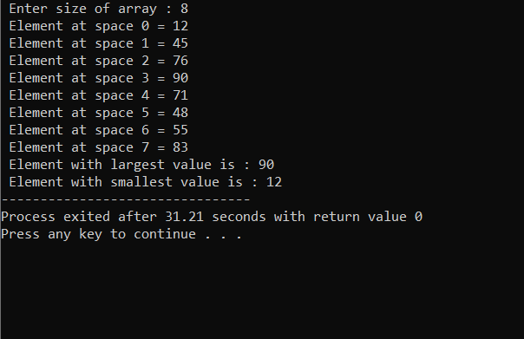

// Q.No 3

// Swapping elemets in an array.

/* void sv(int arr[], int index1, int index2){

int temp = arr[index1];

arr[index1] = arr[index2];

arr[index2] = temp;

}

int main(){

int n;

cout<<" Enter size of array : ";

cin>>n;

int arr[n];

for( int i=0; i<n; i++){

cout<<" Element at space "<<i<<" = ";

cin>>arr[i];

}

cout<<" The array before swapping is : ";

for( int i=0; i<n; i++){

cout<<arr[i]<<" ";

} cout<<endl;

int index1 = 2;

int index2 = 4;

sv(arr, index1, index2);

cout<<" The array after swapping is : ";

for( int i=0; i<n; i++){

cout<<arr[i]<<" ";

}

return 0;

} */

